**AMBER**

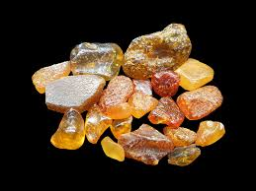 **Name:** Baltic Amber

**Brand:**  Daum

**Model#:** 001

**Color:** Light-Green

**Price: $500 million**